**1. Draw a USE-CASE diagram for Online Voting System using CASE tools.**

***AIM:***

To draw a USE-CASE diagram for Online Voting System using case tools.

***SOFTWARE USED:***

UMBRELLO: 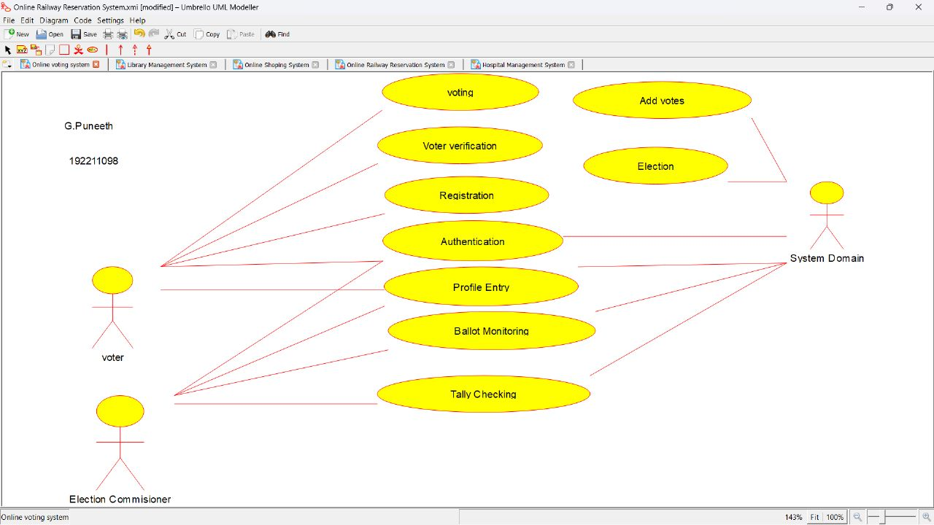

***RESULT:***

USE-CASE diagram for Online Voting System was successfully completed.

2. Draw a USE-CASE diagram for library management System using CASE tools.

***AIM:***

To draw a USE-CASE diagram for Library management System using case tools.

***SOFTWARE USED:***

UMBRELLO:

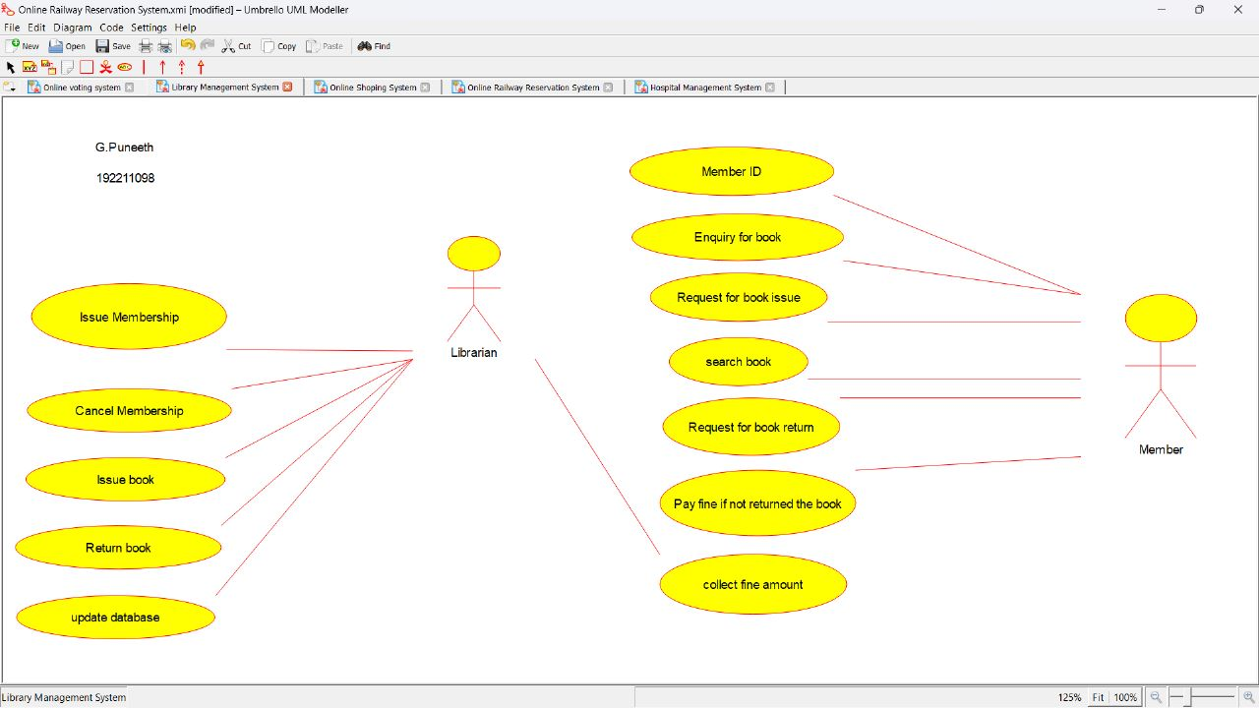

***RESULT:***

USE-CASE diagram for Library management System was successfully completed.

3. Draw and validate the flowchart to compute the quotient and remainder.

***AIM:***

To draw a validate flow chart to compute the quotient and reminder.

***SOFTWARE USED:***

**RAPTOR**

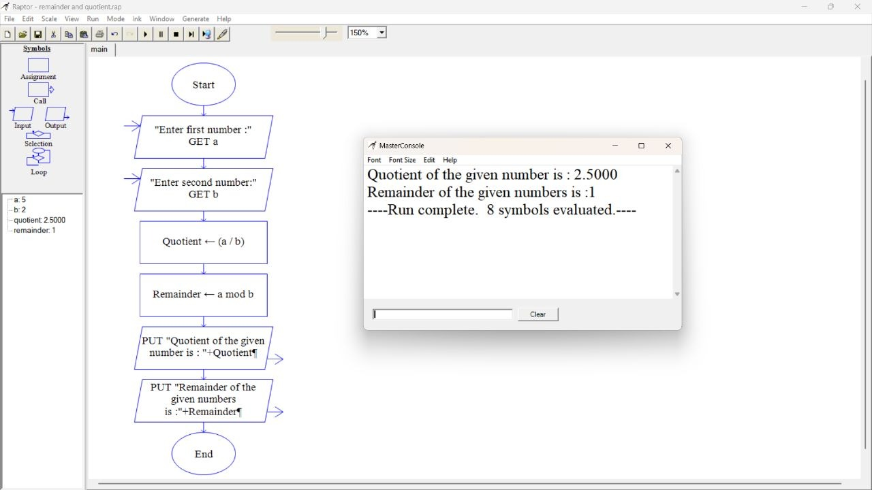

***RESULT:*** The flowchart that validates the quotient and reminder was successfully completed

.

4. Draw a USE-CASE diagram for online shopping system using CASE tools.

***AIM:***

To draw a USE-CASE diagram for Online shopping System using case tools.

***SOFTWARE USED:***

UMBRELLO:

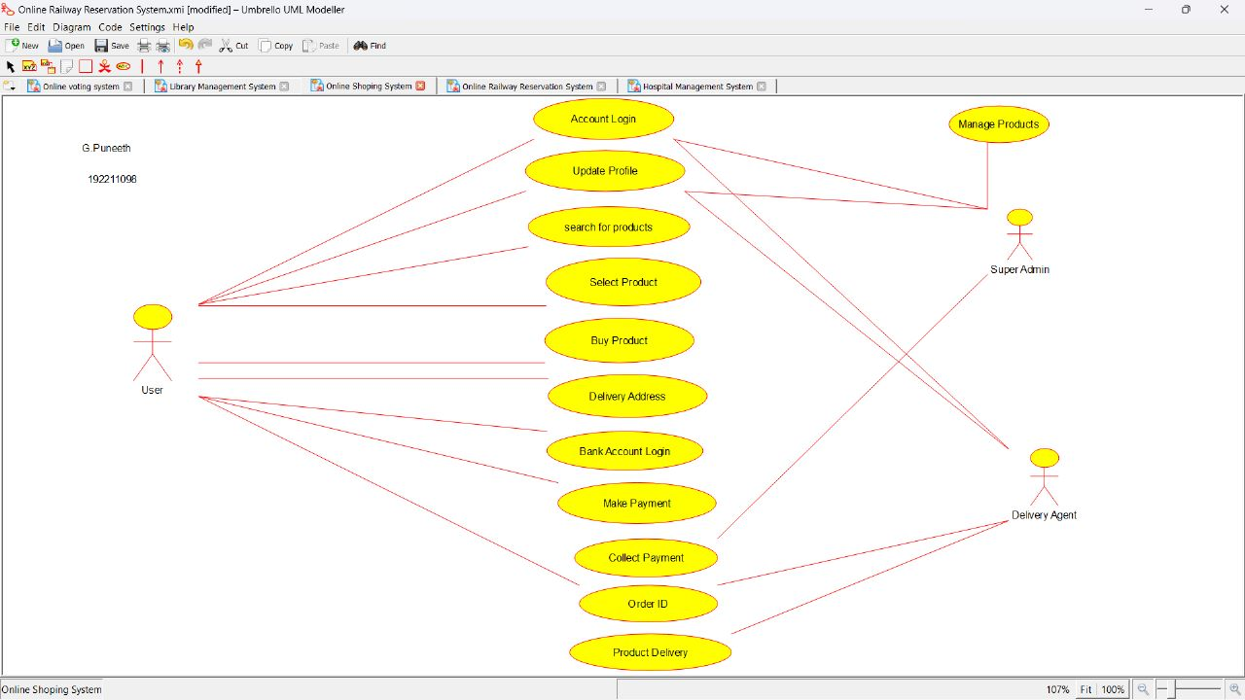

***RESULT:***

USE-CASE diagram for Online shopping System was successfully completed.

5. Draw a USE-CASE diagram for Online Railway Reservation System using CASE tools.

***AIM:***

To draw a USE-CASE diagram for Online Railway Reservation System using case tools.

***SOFTWARE USED:***

UMBRELLO:

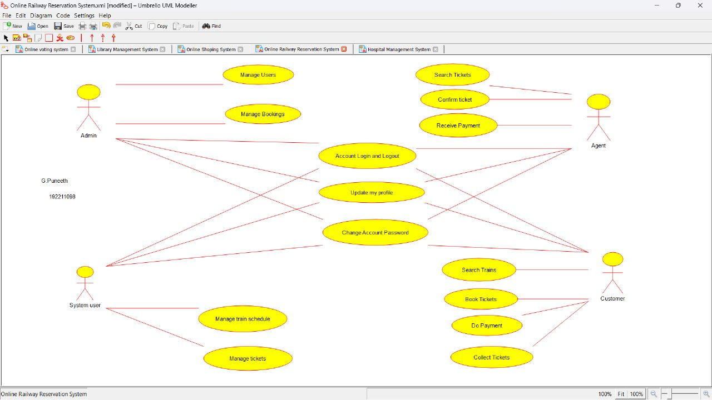

***RESULT:***

USE-CASE diagram for Online Railway Reservation System was successfully completed.

6. Draw a USE-CASE diagram for hospital management system using CASE tools.

***AIM:***

To draw a USE-CASE diagram for Hospital management System using case tools.

***SOFTWARE USED:***

UMBRELLO:

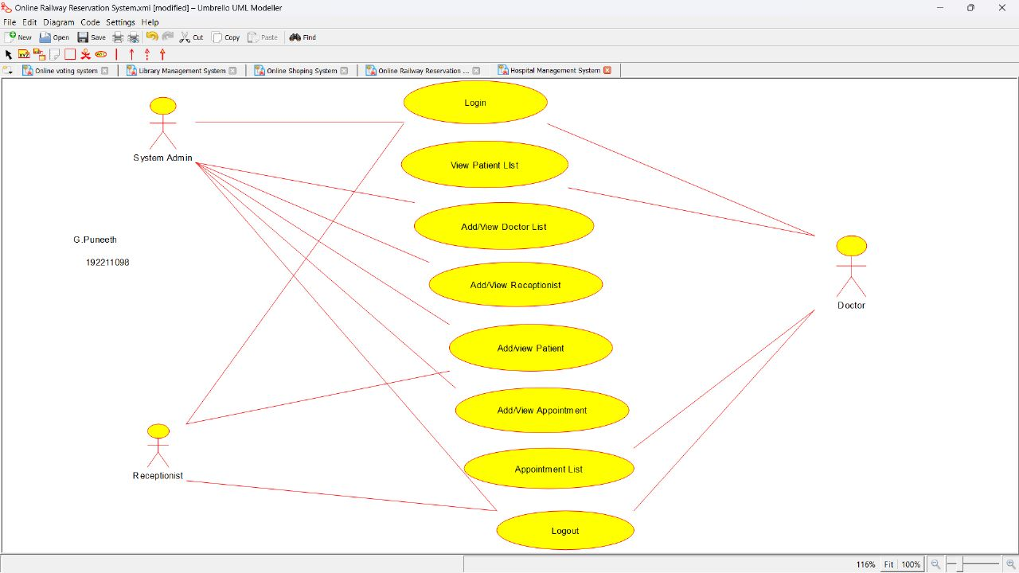

***RESULT:***

USE-CASE diagram for hospital management system was successfully completed.

7. Draw a USE-CASE diagram for ATM System using CASE tools.

***AIM:***

To draw a USE-CASE diagram for ATM System using case tools.

***SOFTWARE USED:***

UMBRELLO:

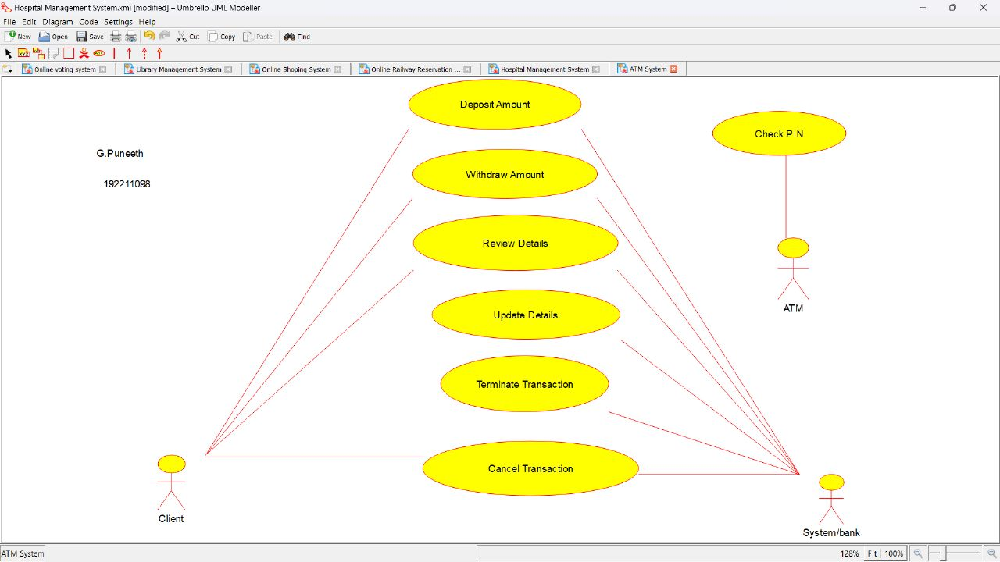

***RESULT:***

USE-CASE diagram for ATM system was successfully completed.

8.Draw a USE-CASE diagram for online college management system using CASE tools.

***AIM:***

To draw a USE-CASE diagram for Online college management System using case tools.

***SOFTWARE USED:***

UMBRELLO:

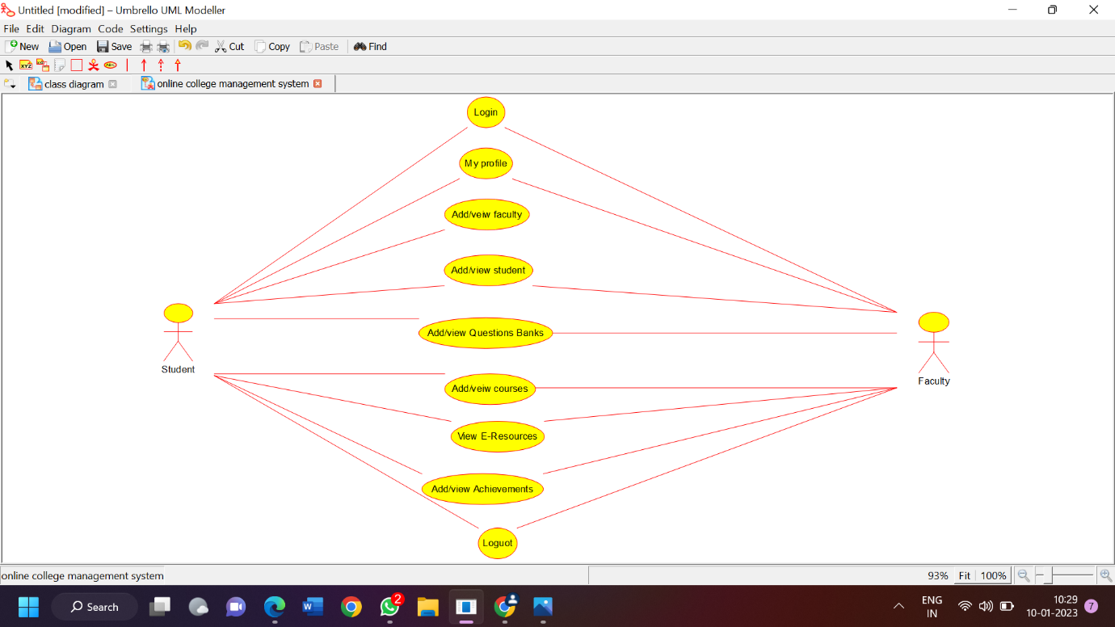

***RESULT:***

USE-CASE diagram for online college management system was successfully completed.

9. Draw a USE-CASE diagram for Online Airline Reservation System using CASE tools.

***AIM:***

To draw a USE-CASE diagram for Online Airline Reservation System using case tools.

***SOFTWARE USED:***

UMBRELLO:

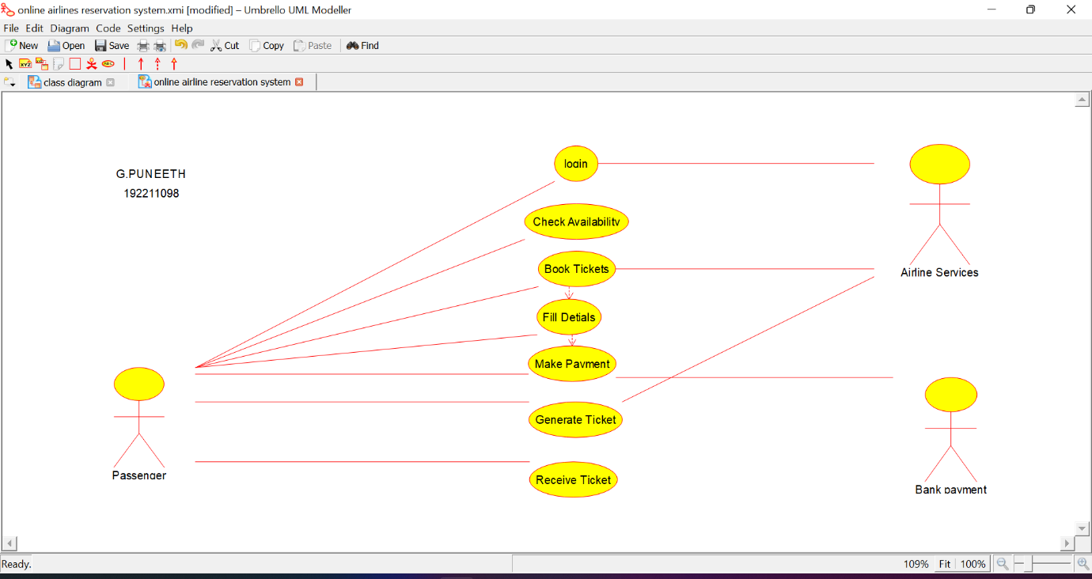

***RESULT:***

USE-CASE diagram for Online Airline Reservation system was successfully completed.

10. Draw a Class diagram for Online Airline Reservation System using CASE tools.

***AIM:***

To draw a class diagram for online airline reservation system.

***SOFTWARE USED:***

UMBRELLO:

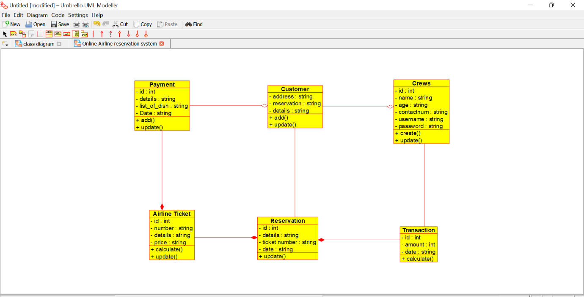

***RESULT:***

Class diagram for Online Airline Reservation system was successfully completed.

11.Draw a class diagram for online voting system using CASE tools.

***AIM:***

To draw a class diagram for online voting system.

***SOFTWARE USED:***

UMBRELLO:

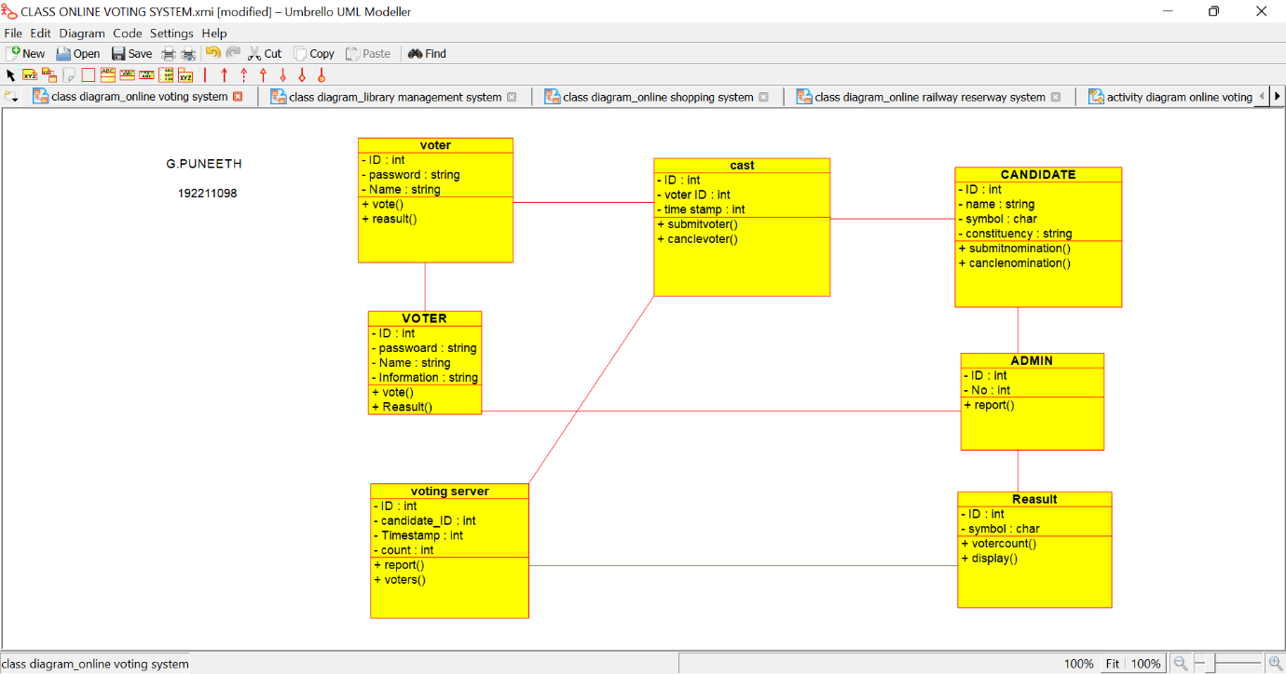

***RESULT:***

Class diagram for online voting system was successfully completed.

12.Draw a class diagram for Library management system using CASE tools.

***AIM:***

To draw a class diagram for Library management system.

***SOFTWARE USED:***

UMBRELLO:

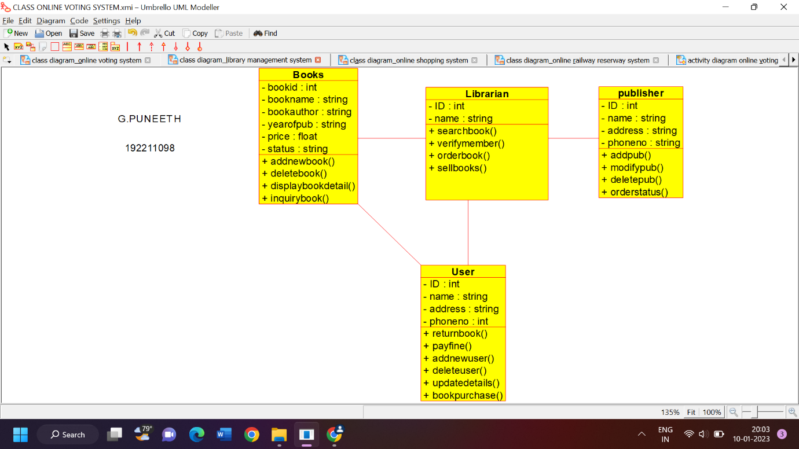

***RESULT:***

Class diagram for Library management system was successfully completed.

13.Draw a class diagram for Online shopping system using CASE tools.

***AIM:***

To draw a class diagram for Online shopping system.

***SOFTWARE USED:***

UMBRELLO:

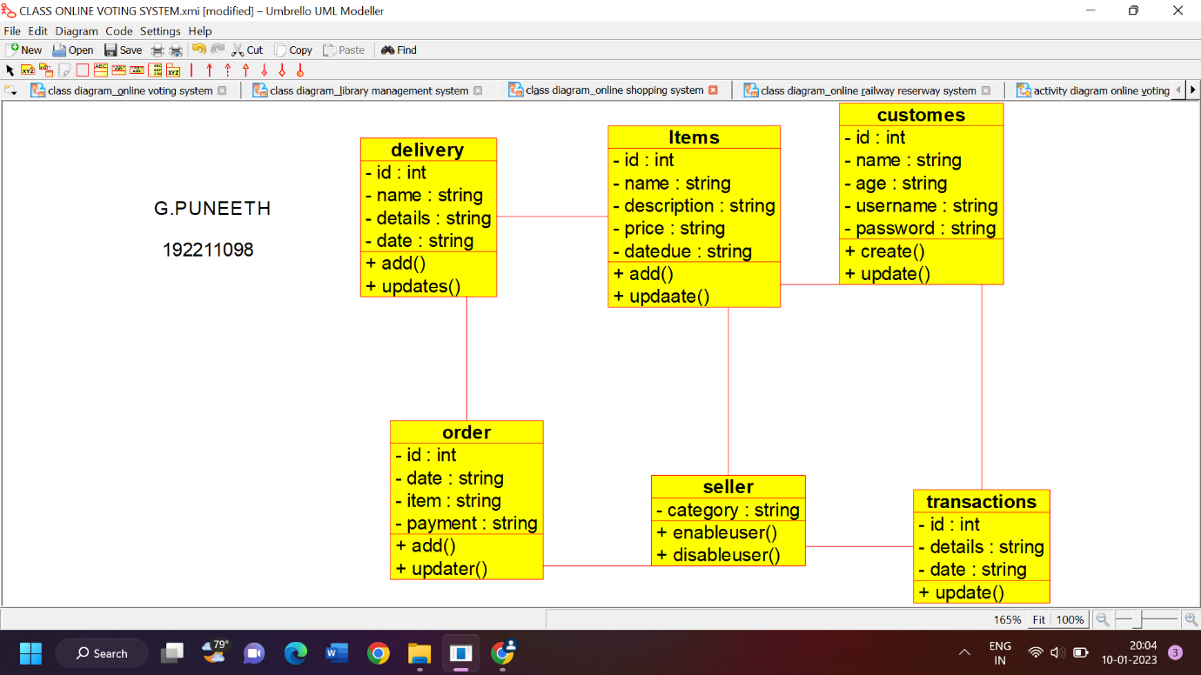

***RESULT:***

Class diagram for Online shopping system was successfully completed.

14.Draw a class diagram for Online Railway reservation system using CASE tools.

***AIM:***

To draw a class diagram for Online Railway reservation system.

***SOFTWARE USED:***

UMBRELLO:

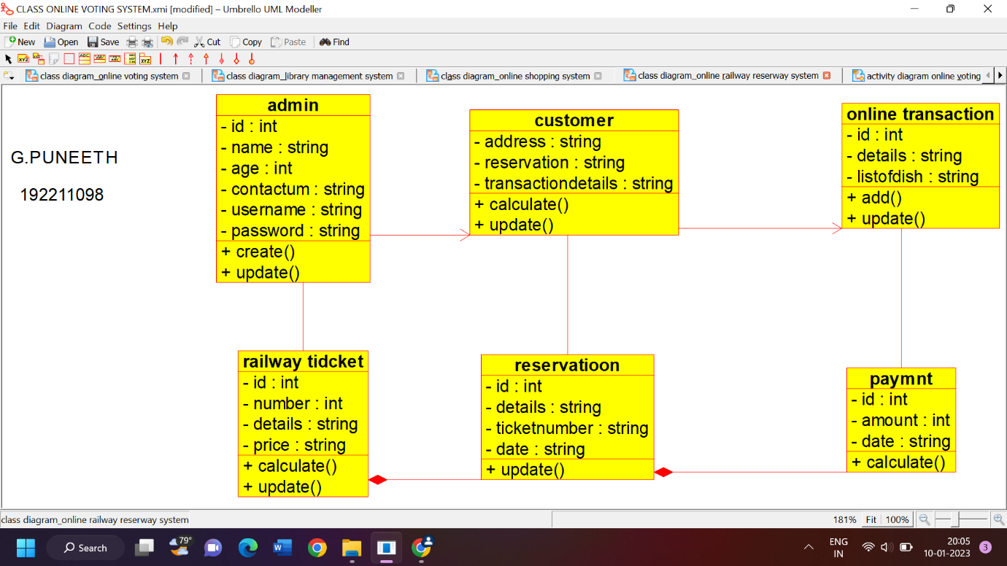

***RESULT:***

Class diagram for Online Railway reservation system was successfully completed.

15. Draw an Activity diagram for Online Voting System using CASE tools.

***AIM:***

To draw an Activity diagram for Online Voting system.

***SOFTWARE USED:***

UMBRELLO:

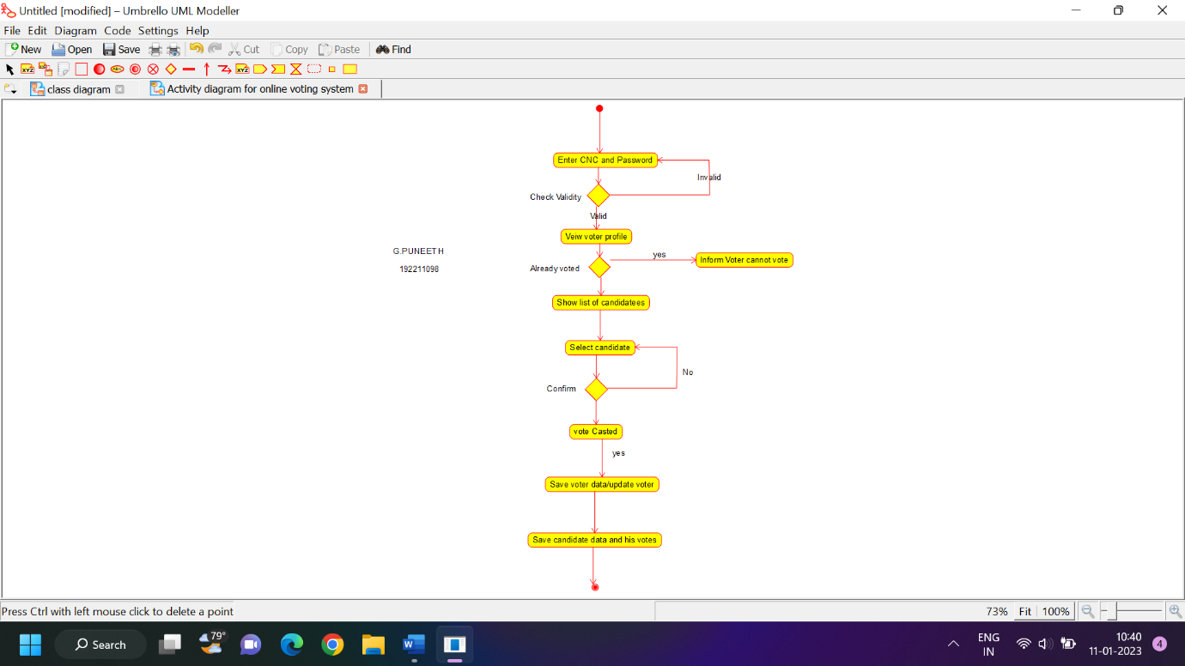

***RESULT:***

Activity diagram for Online Voting System was successfully completed.

16. Draw an Activity diagram for Library Management System using CASE tools.

***AIM:***

To draw an Activity diagram for Library Management System.

***SOFTWARE USED:***

UMBRELLO:

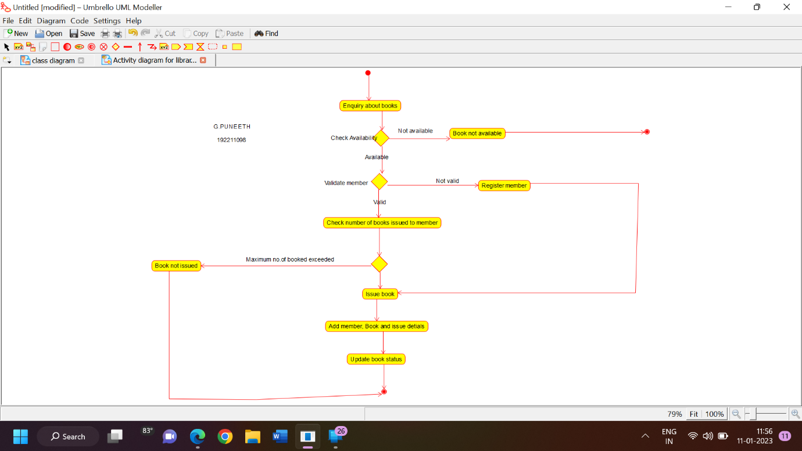

***RESULT:***

Activity diagram for Library Management System was successfully completed.

17. Draw an Activity Online Shopping system diagram for using CASE tools.

***AIM:***

To draw an Activity Online Shopping system diagram.

***SOFTWARE USED:***

UMBRELLO:

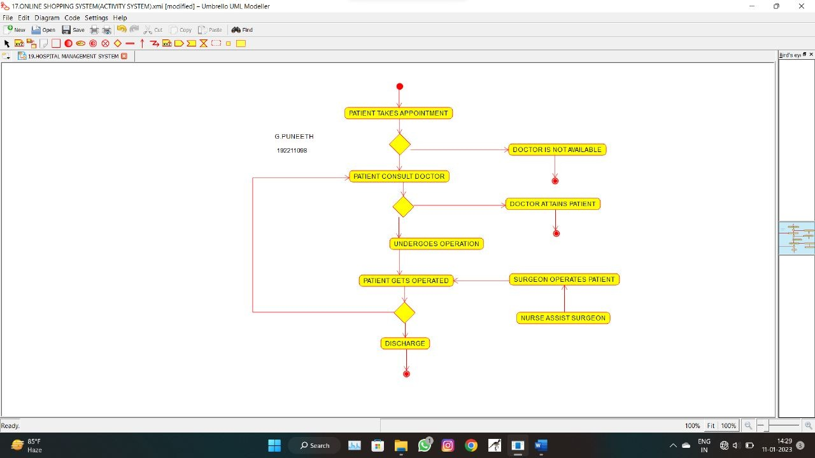

***RESULT:***

Activity diagram Online Shopping system for was successfully completed.

18. Draw an Activity Online Railway Reservation System diagram for using CASE tools.

***AIM:***

To draw an Activity Online Railway Reservation System diagram

***SOFTWARE USED:***

UMBRELLO:

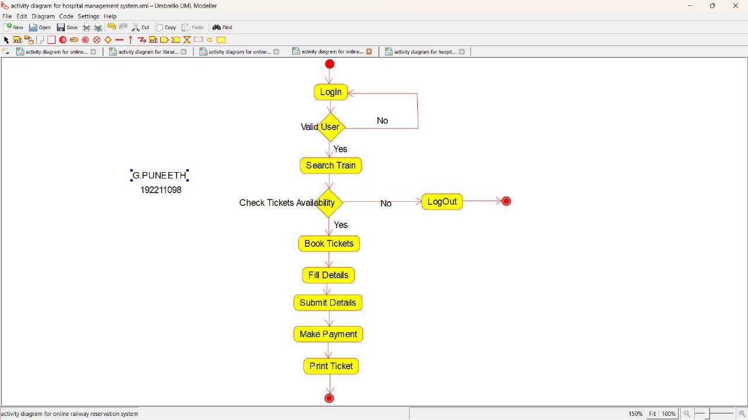

***RESULT:***

Activity diagram Online Railway Reservation System for was successfully completed.

19. Draw an Activity Hospital Management System diagram for using CASE tools.

***AIM:***

To draw an Activity Hospital Management System diagram

***SOFTWARE USED:***

UMBRELLO:

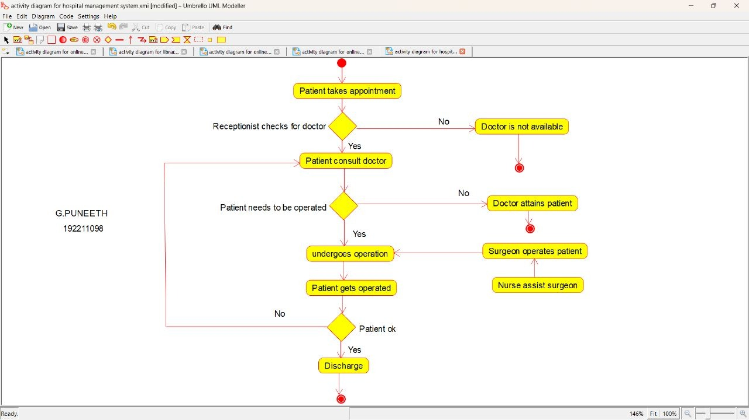

***RESULT:***

Activity diagram Hospital Management System for was successfully completed.

**20.** Using Raptor- Draw the flowchart to check whether the given number is a palindrome or not.

***AIM:***

To draw the flowchart to check whether the given number is a palindrome or not.

***SOFTWARE USED:***

**Raptor**

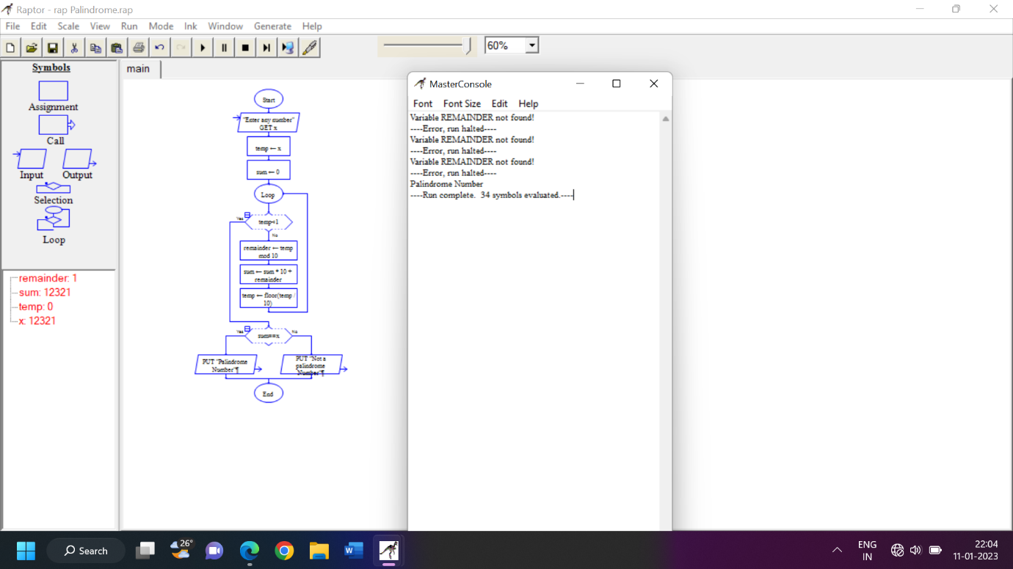

***RESULT:***

The flow chart to check whether the given number is a palindrome or not was successfully completed.

21. Using Raptor- Draw and validate the flowchart to calculate Fibonacci series.

***AIM:***

To draw and validate the flowchart to calculate Fibonacci series.

***SOFTWARE USED:***

**Raptor**

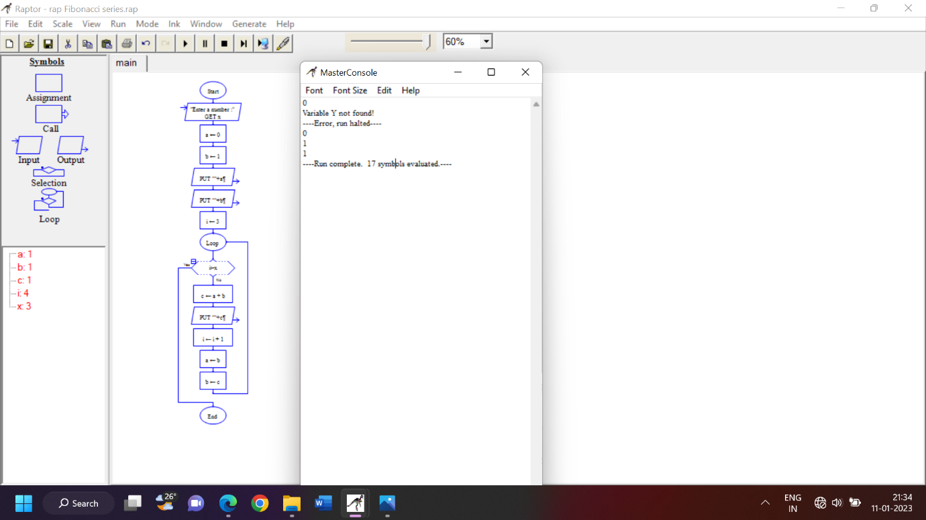

***RESULT:***

To draw and validate the flowchart to calculate Fibonacci series was successfully completed.

22. Using Raptor – Draw and validate the flowchart to swap two characters.

***AIM:***

To draw and validate the flowchart to swap two characters.

***SOFTWARE USED:***

**Raptor**

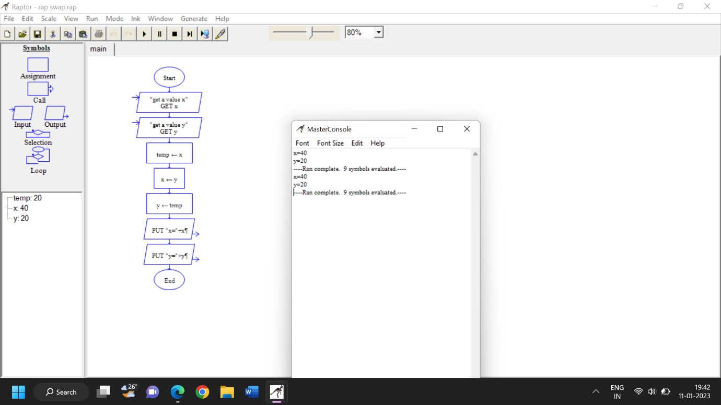

***RESULT:***

To draw and validate the flowchart to swap two characters was successfully completed.

23.Using Raptor – Draw the flowchart to display the length of the string.

***AIM:***

To draw and validate the flowchart to display the length of the string.

***SOFTWARE USED:***

**Raptor**

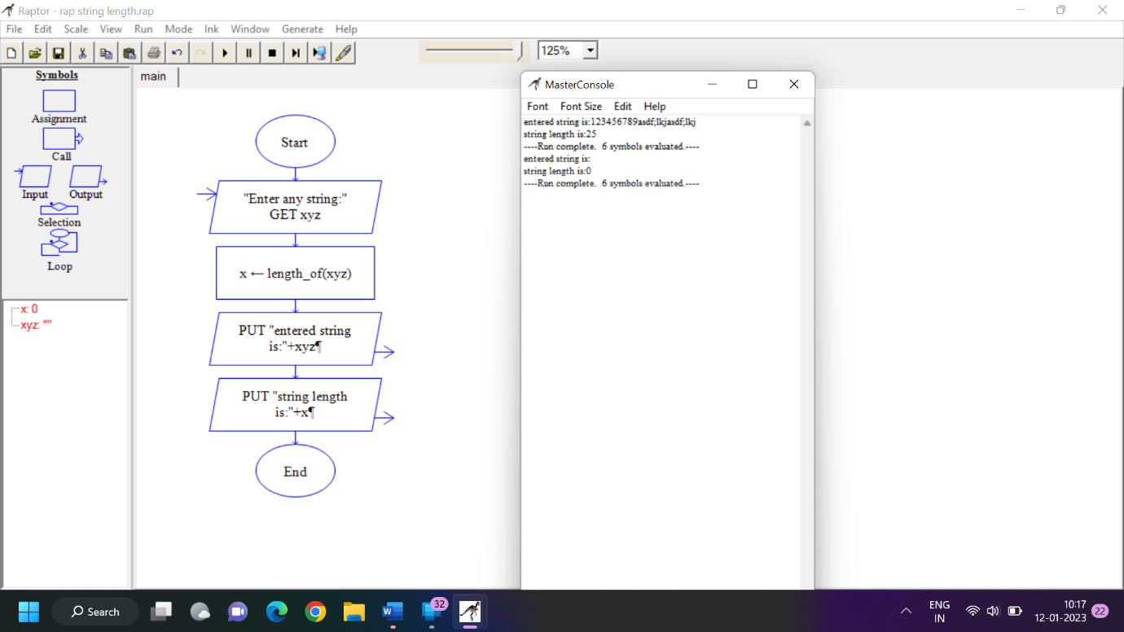

***RESULT:***

To draw and validate the flowchart to display the length of the string was successfully completed.

24.Using Raptor – Draw the flowchart to find whether the given number is prime or not.

***AIM:***

To draw the flowchart to find whether the given number is prime or not.

***SOFTWARE USED:***

**Raptor**

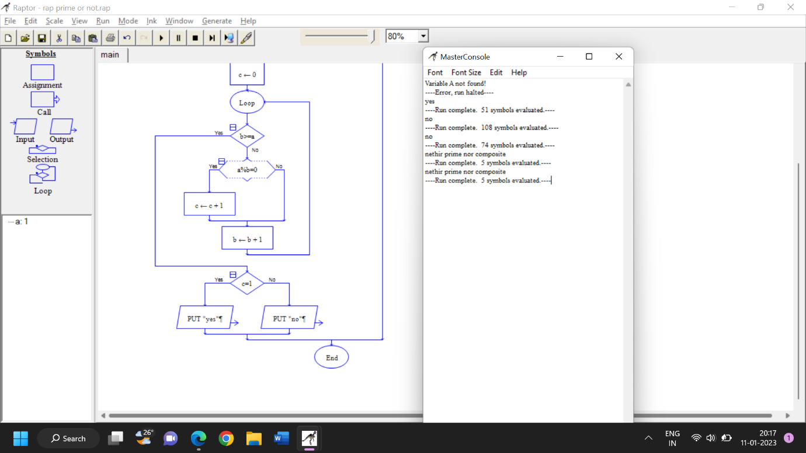

***RESULT:***

To draw the flowchart to find whether the given number is prime or not was successfully completed.

25. Find Cyclomatic Complexity for a graph having number of edges as 13, number of nodes as 17 and number of predicate nodes in the flow graph as 5.

